HOTEL MANAGEMENT SYSTEM

This hotel management project comprises essential tables for rooms, guests, reservations, staff, services, room services, and payments. It facilitates basic functionalities such as room bookings, guest management, service requests, and payment tracking within a small-scale hotel environment, ensuring efficient coordination of hotel operations.

Project by mr.shubham rai

GUIDED BY – MR SAMIR WARSOLKAR SIR

SHUBHAM RAI

[SHUBHAMNEWDAY@GMAIL.COM](mailto:SHUBHAMNEWDAY@GMAIL.COM)

BATCH ID= T315

HOTEL MANAGEMENT SysTEM

PROJECT FOR SQL MODULE

1. Description

This hotel management project is designed to streamline operations within a small-scale hotel environment. It includes essential tables for managing rooms, guests, reservations, staff, services, room services, and payments. The system enables functionalities such as booking rooms, managing guest information, handling service requests, and tracking payments. Through effective coordination of these components, the project aims to enhance efficiency and customer satisfaction in hotel operations.

This database contain 7 tables:

1. ROOMS
2. GUESTS
3. RESERVATIONS
4. STAFF
5. SERVICES
6. ROOM_SERVICES
7. PAYMENTS

How these tables/ entities are related to each other is shown pictorially on next

Page through ER diagram ,i.e.,ENTITY RELATIONSHIP DIAGRAM.

2.ER.Diagram (Entity Relation- Diagram) for HOTEL MANAGEMENT SYSTEM:

TABLE GUESTS

Guest_id(PK)

First_name

Last_name

Email

Phone_number

CREATE STAFF

Staff_id(PK)

First_name

Last_name

Position

Department

Email

Phone_number

TABLE ROOMS

Room_id(PK)

Room_number

Room_type

Rate_per_night

Status

TABLE RESERVATIONS

Reservation_id(PK)

Guest_id(FK)

Room_id(FK)

Check_in_date

Check_in_out

Total_amount

Payment_status

TABLE ROOM_SERVICES

Room_service_id(PK)

Reservation_id(FK)

Service_id(FK)

Quantity

Total_price

TABLE SERVICES

Service_id(PK)

Service_name

Description

Price

TABLE PAYMENTS

Payment_id(PK)

Reservation_id(FK)

Payment_date

Amount_paid

Payment_method

1. TABLE DESCRIPTIONS

1.ROOM.

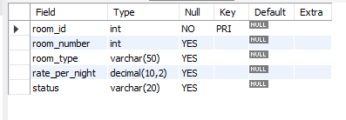

1. GUESTS

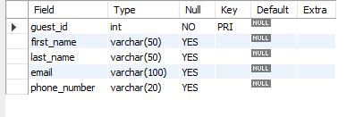

1. RESERVATIONS

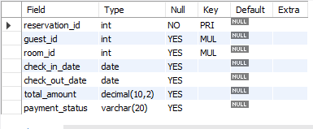

1. STAFF:

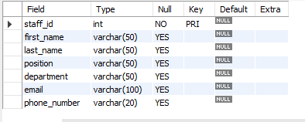

1. SERVICES:

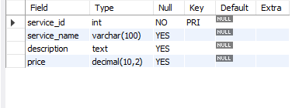

1. ROOM_SERVICES:

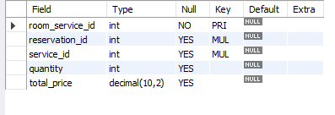

1. PAYMENTS:

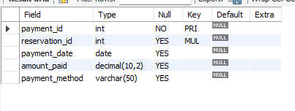

1. COMMANDS:

CREATE DATABASE : HOTEL MANAGEMENT SYSTEM

SELECT DATABASE HOTEL_MANAGEMENT_SYSTEM;

-- Rooms Table

CREATE TABLE Rooms (

room_id INT PRIMARY KEY,

room_number INT,

room_type VARCHAR(50),

rate_per_night DECIMAL(10, 2),

status VARCHAR(20)

);

-- Guests Table

CREATE TABLE Guests (

guest_id INT PRIMARY KEY,

first_name VARCHAR(50),

last_name VARCHAR(50),

email VARCHAR(100),

phone_number VARCHAR(20)

);

-- Reservations Table

CREATE TABLE Reservations (

reservation_id INT PRIMARY KEY,

guest_id INT,

room_id INT,

check_in_date DATE,

check_out_date DATE,

total_amount DECIMAL(10, 2),

payment_status VARCHAR(20),

FOREIGN KEY (guest_id) REFERENCES Guests(guest_id),

FOREIGN KEY (room_id) REFERENCES Rooms(room_id)

);

-- Staff Table

CREATE TABLE Staff (

staff_id INT PRIMARY KEY,

first_name VARCHAR(50),

last_name VARCHAR(50),

position VARCHAR(50),

department VARCHAR(50),

email VARCHAR(100),

phone_number VARCHAR(20)

);

-- Services Table

CREATE TABLE Services (

service_id INT PRIMARY KEY,

service_name VARCHAR(100),

description TEXT,

price DECIMAL(10, 2)

);

-- Room_Services Table

CREATE TABLE Room_Services (

room_service_id INT PRIMARY KEY,

reservation_id INT,

service_id INT,

quantity INT,

total_price DECIMAL(10, 2),

FOREIGN KEY (reservation_id) REFERENCES Reservations(reservation_id),

FOREIGN KEY (service_id) REFERENCES Services(service_id)

);

-- Payments Table

CREATE TABLE Payments (

payment_id INT PRIMARY KEY,

reservation_id INT,

payment_date DATE,

amount_paid DECIMAL(10, 2),

payment_method VARCHAR(50),

FOREIGN KEY (reservation_id) REFERENCES Reservations(reservation_id)

);

TABLE ROOMS:

INSERT INTO Rooms (room_id, room_number, room_type, rate_per_night, status) VALUES

(1, 101, 'Single', 50.00, 'Available'),

(2, 102, 'Single', 50.00, 'Available'),

(3, 103, 'Single', 50.00, 'Occupied'),

(4, 104, 'Single', 50.00, 'Available'),

(5, 105, 'Single', 50.00, 'Available'),

(6, 201, 'Double', 75.00, 'Available'),

(7, 202, 'Double', 75.00, 'Available'),

(8, 203, 'Double', 75.00, 'Available'),

(9, 204, 'Double', 75.00, 'Available'),

(10, 205, 'Double', 75.00, 'Available'),

(11, 301, 'Suite', 150.00, 'Available'),

(12, 302, 'Suite', 150.00, 'Available'),

(13, 303, 'Suite', 150.00, 'Available'),

(14, 304, 'Suite', 150.00, 'Available'),

(15, 305, 'Suite', 150.00, 'Available'),

(16, 401, 'Penthouse', 300.00, 'Available'),

(17, 402, 'Penthouse', 300.00, 'Available'),

(18, 403, 'Penthouse', 300.00, 'Available'),

(19, 404, 'Penthouse', 300.00, 'Available'),

(20, 405, 'Penthouse', 300.00, 'Available'),

(21, 501, 'Family', 100.00, 'Available'),

(22, 502, 'Family', 100.00, 'Available'),

(23, 503, 'Family', 100.00, 'Available'),

(24, 504, 'Family', 100.00, 'Available'),

(25, 505, 'Family', 100.00, 'Available');

TABLE GUESTS:

INSERT INTO Guests (guest_id, first_name, last_name, email, phone_number) VALUES

(1, 'John', 'Doe', 'john.doe@example.com', '+1234567890'),

(2, 'Jane', 'Smith', 'jane.smith@example.com', '+1987654321'),

(3, 'Michael', 'Johnson', 'michael.johnson@example.com', '+1122334455'),

(4, 'Emily', 'Brown', 'emily.brown@example.com', '+1567890123'),

(5, 'David', 'Wilson', 'david.wilson@example.com', '+1324354657'),

(6, 'Sarah', 'Anderson', 'sarah.anderson@example.com', '+1789054321'),

(7, 'Christopher', 'Martinez', 'christopher.martinez@example.com', '+1432987654'),

(8, 'Amanda', 'Taylor', 'amanda.taylor@example.com', '+1876543210'),

(9, 'James', 'Thomas', 'james.thomas@example.com', '+1247389056'),

(10, 'Jennifer', 'Hernandez', 'jennifer.hernandez@example.com', '+1987654321'),

(11, 'Matthew', 'Young', 'matthew.young@example.com', '+1123456789'),

(12, 'Jessica', 'King', 'jessica.king@example.com', '+1654327890'),

(13, 'Daniel', 'Lee', 'daniel.lee@example.com', '+1789054321'),

(14, 'Ashley', 'Clark', 'ashley.clark@example.com', '+1432987654'),

(15, 'Andrew', 'Lewis', 'andrew.lewis@example.com', '+1890765432'),

(16, 'Elizabeth', 'Walker', 'elizabeth.walker@example.com', '+1247389056'),

(17, 'Ryan', 'Hall', 'ryan.hall@example.com', '+1324354657'),

(18, 'Olivia', 'Allen', 'olivia.allen@example.com', '+1567890123'),

(19, 'Nicholas', 'Green', 'nicholas.green@example.com', '+1234567890'),

(20, 'Samantha', 'Baker', 'samantha.baker@example.com', '+1987654321'),

(21, 'Tyler', 'Gonzalez', 'tyler.gonzalez@example.com', '+1122334455'),

(22, 'Madison', 'Nelson', 'madison.nelson@example.com', '+1789054321'),

(23, 'Justin', 'Carter', 'justin.carter@example.com', '+1432987654'),

(24, 'Emma', 'Hill', 'emma.hill@example.com', '+1876543210'),

(25, 'Brandon', 'Wright', 'brandon.wright@example.com', '+1247389056');

TABLE RESERVATIONS:

INSERT INTO Reservations (reservation_id, guest_id, room_id, check_in_date, check_out_date, total_amount, payment_status) VALUES

(1, 1, 1, '2024-05-01', '2024-05-05', 200.00, 'Paid'),

(2, 2, 6, '2024-05-03', '2024-05-07', 300.00, 'Paid'),

(3, 3, 11, '2024-05-02', '2024-05-06', 600.00, 'Paid'),

(4, 4, 16, '2024-05-04', '2024-05-08', 1200.00, 'Paid'),

(5, 5, 21, '2024-05-01', '2024-05-03', 200.00, 'Paid'),

(6, 6, 2, '2024-05-06', '2024-05-08', 100.00, 'Paid'),

(7, 7, 7, '2024-05-02', '2024-05-04', 150.00, 'Paid'),

(8, 8, 12, '2024-05-03', '2024-05-07', 600.00, 'Paid'),

(9, 9, 17, '2024-05-05', '2024-05-09', 1200.00, 'Paid'),

(10, 10, 22, '2024-05-01', '2024-05-05', 400.00, 'Paid'),

(11, 11, 3, '2024-05-07', '2024-05-10', 150.00, 'Paid'),

(12, 12, 8, '2024-05-04', '2024-05-06', 300.00, 'Paid'),

(13, 13, 13, '2024-05-06', '2024-05-09', 450.00, 'Paid'),

(14, 14, 18, '2024-05-08', '2024-05-12', 900.00, 'Paid'),

(15, 15, 23, '2024-05-02', '2024-05-04', 200.00, 'Paid'),

(16, 16, 4, '2024-05-09', '2024-05-13', 200.00, 'Paid'),

(17, 17, 9, '2024-05-05', '2024-05-07', 150.00, 'Paid'),

(18, 18, 14, '2024-05-07', '2024-05-10', 450.00, 'Paid'),

(19, 19, 19, '2024-05-03', '2024-05-07', 400.00, 'Paid'),

(20, 20, 24, '2024-05-01', '2024-05-03', 200.00, 'Paid'),

(21, 21, 5, '2024-05-08', '2024-05-11', 300.00, 'Paid'),

(22, 22, 10, '2024-05-04', '2024-05-06', 150.00, 'Paid'),

(23, 23, 15, '2024-05-06', '2024-05-08', 300.00, 'Paid'),

(24, 24, 20, '2024-05-02', '2024-05-06', 400.00, 'Paid'),

(25, 25, 25, '2024-05-09', '2024-05-13', 400.00, 'Paid');

TABLE STAFF:

INSERT INTO Staff (staff_id, first_name, last_name, position, department, email, phone_number) VALUES

(1, 'Michael', 'Smith', 'Manager', 'Management', 'michael.smith@example.com', '+1234567890'),

(2, 'Jennifer', 'Johnson', 'Front Desk Clerk', 'Front Desk', 'jennifer.johnson@example.com', '+1987654321'),

(3, 'Christopher', 'Williams', 'Housekeeping Supervisor', 'Housekeeping', 'christopher.williams@example.com', '+1122334455'),

(4, 'Jessica', 'Jones', 'Maintenance Technician', 'Maintenance', 'jessica.jones@example.com', '+1567890123'),

(5, 'Matthew', 'Brown', 'Restaurant Manager', 'Food & Beverage', 'matthew.brown@example.com', '+1324354657'),

(6, 'Amanda', 'Garcia', 'Concierge', 'Guest Services', 'amanda.garcia@example.com', '+1789054321'),

(7, 'David', 'Rodriguez', 'Bellhop', 'Guest Services', 'david.rodriguez@example.com', '+1432987654'),

(8, 'Ashley', 'Martinez', 'Chef', 'Food & Beverage', 'ashley.martinez@example.com', '+1876543210'),

(9, 'John', 'Hernandez', 'Bartender', 'Food & Beverage', 'john.hernandez@example.com', '+1247389056'),

(10, 'Emily', 'Lopez', 'Spa Therapist', 'Spa', 'emily.lopez@example.com', '+1987654321'),

(11, 'Daniel', 'Gonzalez', 'Fitness Instructor', 'Fitness Center', 'daniel.gonzalez@example.com', '+1123456789'),

(12, 'Samantha', 'Perez', 'Event Coordinator', 'Events', 'samantha.perez@example.com', '+1654327890'),

(13, 'Ryan', 'Wilson', 'Security Officer', 'Security', 'ryan.wilson@example.com', '+1789054321'),

(14, 'Olivia', 'Flores', 'Valet Attendant', 'Guest Services', 'olivia.flores@example.com', '+1432987654'),

(15, 'Nicholas', 'Torres', 'IT Specialist', 'IT', 'nicholas.torres@example.com', '+1890765432'),

(16, 'Emma', 'Rivera', 'Housekeeping', 'Housekeeping', 'emma.rivera@example.com', '+1247389056'),

(17, 'Brandon', 'Long', 'Front Desk Clerk', 'Front Desk', 'brandon.long@example.com', '+1324354657'),

(18, 'Madison', 'Scott', 'Housekeeping', 'Housekeeping', 'madison.scott@example.com', '+1567890123'),

(19, 'Tyler', 'Nguyen', 'Chef', 'Food & Beverage', 'tyler.nguyen@example.com', '+1234567890'),

(20, 'Elizabeth', 'Kim', 'Concierge', 'Guest Services', 'elizabeth.kim@example.com', '+1987654321'),

(21, 'Justin', 'Harris', 'Front Desk Clerk', 'Front Desk', 'justin.harris@example.com', '+1122334455'),

(22, 'Hannah', 'Lee', 'Housekeeping', 'Housekeeping', 'hannah.lee@example.com', '+1789054321'),

(23, 'William', 'King', 'Bellhop', 'Guest Services', 'william.king@example.com', '+1432987654'),

(24, 'Taylor', 'Wright', 'Maintenance Technician', 'Maintenance', 'taylor.wright@example.com', '+1876543210'),

(25, 'Lauren', 'Green', 'Event Coordinator', 'Events', 'lauren.green@example.com', '+1247389056');

TABLE SERVICES:

INSERT INTO Services (service_id, service_name, description, price) VALUES

(1, 'Room Cleaning', 'Daily cleaning of the guest room', 20.00),

(2, 'Laundry Service', 'Washing and ironing of clothes', 15.00),

(3, 'Room Service', 'Delivery of food and beverages to the guest room', 10.00),

(4, 'Spa Massage', 'Relaxing massage at the hotel spa', 50.00),

(5, 'Fitness Training', 'Personal training session at the fitness center', 30.00),

(6, 'Airport Shuttle', 'Transportation service to and from the airport', 25.00),

(7, 'Valet Parking', 'Convenient parking service with valet assistance', 10.00),

(8, 'Concierge Assistance', 'Assistance with reservations, recommendations, and arrangements', 0.00),

(9, 'In-Room Dining', 'Selection of meals and beverages delivered to the guest room', 20.00),

(10, 'WiFi Access', 'High-speed internet access throughout the hotel', 0.00),

(11, 'Business Center', 'Access to computers, printers, and other office equipment', 0.00),

(12, 'Swimming Pool Access', 'Access to the hotel swimming pool', 0.00),

(13, 'Sauna Session', 'Relaxing sauna session at the hotel spa', 20.00),

(14, 'Conference Room Rental', 'Rental of conference room for meetings or events', 100.00),

(15, 'Babysitting Service', 'Professional childcare service for guests with children', 20.00),

(16, 'Car Rental', 'Rental of vehicles for transportation during the stay', 50.00),

(17, 'Tour Booking', 'Arrangement of guided tours and excursions', 0.00),

(18, 'Gift Shop Purchases', 'Purchase of souvenirs and gifts from the hotel gift shop', 0.00),

(19, 'Pet Sitting Service', 'Professional pet care service for guests traveling with pets', 25.00),

(20, 'Dry Cleaning', 'Dry cleaning and pressing of clothing items', 10.00),

(21, 'Shoe Shine Service', 'Shoe shining service to keep footwear in top condition', 5.00),

(22, 'In-Room Safe Rental', 'Rental of in-room safe for storing valuable items', 5.00),

(23, 'Limousine Service', 'Luxury transportation service with a chauffeur-driven limousine', 100.00),

(24, 'Golf Course Access', 'Access to the hotel golf course for guests who enjoy golfing', 50.00),

(25, 'Photocopying Service', 'Photocopying service for documents and other materials', 0.10);

TABLE ROOM_SERVICES:

INSERT INTO Room_Services (room_service_id, reservation_id, service_id, quantity, total_price) VALUES

(1, 1, 3, 2, 20.00),

(2, 2, 9, 1, 20.00),

(3, 3, 4, 1, 50.00),

(4, 4, 1, 1, 20.00),

(5, 5, 7, 1, 10.00),

(6, 6, 2, 3, 45.00),

(7, 7, 5, 1, 30.00),

(8, 8, 8, 1, 0.00),

(9, 9, 10, 1, 0.00),

(10, 10, 14, 1, 100.00),

(11, 11, 17, 2, 0.00),

(12, 12, 21, 1, 5.00),

(13, 13, 12, 1, 0.00),

(14, 14, 19, 1, 25.00),

(15, 15, 20, 2, 20.00),

(16, 16, 6, 1, 25.00),

(17, 17, 11, 1, 0.00),

(18, 18, 3, 2, 20.00),

(19, 19, 16, 1, 50.00),

(20, 20, 22, 1, 5.00),

(21, 21, 13, 1, 20.00),

(22, 22, 18, 1, 0.00),

(23, 23, 23, 1, 100.00),

(24, 24, 24, 1, 50.00),

(25, 25, 25, 10, 1.00);

TABLE PAYMENTS:

INSERT INTO Payments (payment_id, reservation_id, payment_date, amount_paid, payment_method) VALUES

(1, 1, '2024-05-05', 200.00, 'Credit Card'),

(2, 2, '2024-05-07', 300.00, 'Cash'),

(3, 3, '2024-05-06', 600.00, 'Credit Card'),

(4, 4, '2024-05-08', 1200.00, 'Credit Card'),

(5, 5, '2024-05-03', 200.00, 'Cash'),

(6, 6, '2024-05-08', 100.00, 'Credit Card'),

(7, 7, '2024-05-04', 150.00, 'Cash'),

(8, 8, '2024-05-07', 600.00, 'Credit Card'),

(9, 9, '2024-05-09', 1200.00, 'Credit Card'),

(10, 10, '2024-05-05', 400.00, 'Cash'),

(11, 11, '2024-05-10', 150.00, 'Credit Card'),

(12, 12, '2024-05-06', 300.00, 'Cash'),

(13, 13, '2024-05-09', 450.00, 'Credit Card'),

(14, 14, '2024-05-12', 900.00, 'Credit Card'),

(15, 15, '2024-05-04', 200.00, 'Cash'),

(16, 16, '2024-05-13', 200.00, 'Credit Card'),

(17, 17, '2024-05-07', 150.00, 'Cash'),

(18, 18, '2024-05-10', 450.00, 'Credit Card'),

(19, 19, '2024-05-07', 400.00, 'Cash'),

(20, 20, '2024-05-03', 200.00, 'Credit Card'),

(21, 21, '2024-05-11', 300.00, 'Cash'),

(22, 22, '2024-05-06', 150.00, 'Credit Card'),

(23, 23, '2024-05-08', 300.00, 'Cash'),

(24, 24, '2024-05-06', 400.00, 'Credit Card'),

(25, 25, '2024-05-13', 400.00, 'Cash');

1. SUB-QUERIES:

1. *Query 1*: Retrieve the total amount paid for all reservations.

SELECT SUM(amount_paid) AS total_amount_paid

FROM Payments;



2. *Query 2*: Get the average rate per night for all room types.

SELECT room_type, AVG(rate_per_night) AS average_rate_per_night

FROM Rooms

GROUP BY room_type;

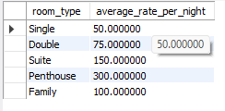

3. *Query 3*: Count the number of reservations made by guests whose last name starts with 'S'.

SELECT COUNT(*) AS reservation_count

FROM Reservations

WHERE guest_id IN (

SELECT guest_id

FROM Guests

WHERE last_name LIKE 'S%'

);

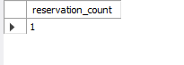

4. *Query 4*: Retrieve the service names and their prices for services with a price greater than $20.00.

SELECT service_name, price

FROM Services

WHERE price > 20.00;

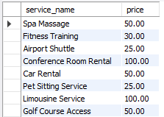

5. *Query 5*: List the staff members who work in the Front Desk department.

sql

SELECT *

FROM Staff

WHERE department = 'Front Desk';

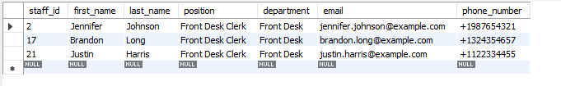

1. *Subquery Question 1*: Retrieve the first and last names of guests who made reservations with a total amount greater than the average total amount of all reservations.

sql

SELECT first_name, last_name

FROM Guests

WHERE guest_id IN (

SELECT guest_id

FROM Reservations

WHERE total_amount > (

SELECT AVG(total_amount)

FROM Reservations

)

);

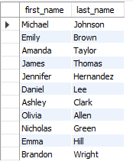

2. *Subquery Question 2*: Get the room numbers and types for rooms that have been booked for reservations with a payment status of 'Paid'.

sql

SELECT room_number, room_type

FROM Rooms

WHERE room_id IN (

SELECT room_id

FROM Reservations

WHERE payment_status = 'Paid'

);

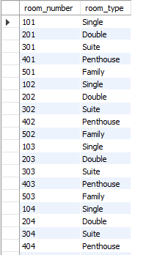

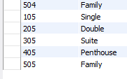

3. *Subquery Question 3*: List the first and last names of guests who have booked the most expensive room type.

sql

SELECT first_name, last_name

FROM Guests

WHERE guest_id IN (

SELECT guest_id

FROM Reservations

WHERE room_id IN (

SELECT room_id

FROM Rooms

WHERE room_type = (

SELECT room_type

FROM Rooms

ORDER BY rate_per_night DESC

LIMIT 1

)

)

);

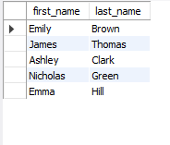

4. *Subquery Question 4*: Display the service names for services that have been booked by guests whose last name is 'Martinez'.

sql

SELECT service_name

FROM Services

WHERE service_id IN (

SELECT service_id

FROM Room_Services

WHERE reservation_id IN (

SELECT reservation_id

FROM Reservations

WHERE guest_id IN (

SELECT guest_id

FROM Guests

WHERE last_name = 'Martinez'

)

)

);

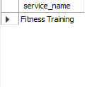

5. *Subquery Question 5*: Show the total amount paid by guests who booked rooms with a room rate per night greater than the average room rate per night.

sql

SELECT SUM(amount_paid) AS total_amount_paid

FROM Payments

WHERE reservation_id IN (

SELECT reservation_id

FROM Reservations

WHERE room_id IN (

SELECT room_id

FROM Rooms WHERE rate_per_night > ( SELECT AVG(rate_per_night)

FROM Rooms ) ));

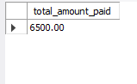

1. *Query 1*: Retrieve the details of all reservations along with the corresponding guest's first and last name.

SELECT Reservations.reservation_id, Guests.first_name, Guests.last_name

FROM Reservations

JOIN Guests ON Reservations.guest_id = Guests.guest_id;

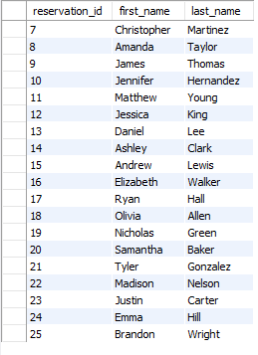

2. *Query 2*: Get the room number and type for each reservation.

SELECT Reservations.reservation_id, Rooms.room_number, Rooms.room_type

FROM Reservations

JOIN Rooms ON Reservations.room_id = Rooms.room_id;

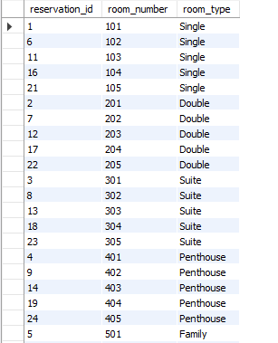

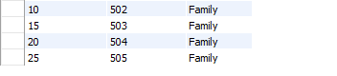

3. *Query 3*: List the total amount paid for each reservation along with the payment status.

SELECT Reservations.reservation_id, Payments.amount_paid, Reservations.payment_status

FROM Reservations

JOIN Payments ON Reservations.reservation_id = Payments.reservation_id;

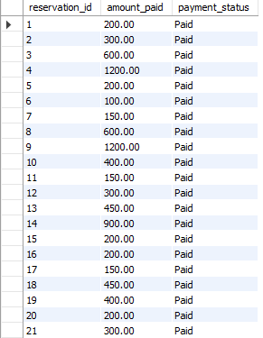

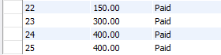

4. *Query 4*: Display the first and last names of guests along with their email addresses.

SELECT Guests.first_name, Guests.last_name, Guests.email

FROM Guests;

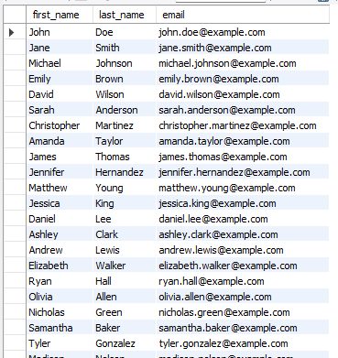

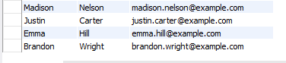

5. *Query 5*: Show the position and department of each staff member.

SELECT Staff.first_name, Staff.last_name, Staff.position, Staff.department

FROM Staff;

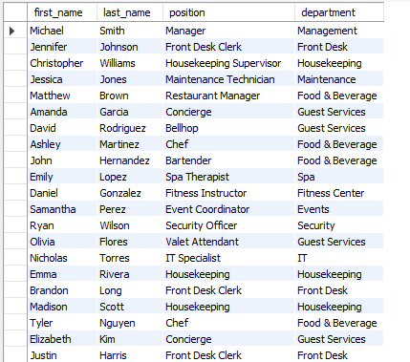



OBSERVATION

The hotel management project demonstrates a well-structured database schema for organizing essential hotel operations. It efficiently manages room bookings, guest information, service requests, and payment tracking. The project's simplicity makes it suitable for small-scale hotel environments, ensuring effective coordination of operations while prioritizing customer satisfaction. However, it may benefit from additional features such as reporting capabilities or integration with external systems for enhanced functionality and scalability.

CONCLUTION

The hotel management system project involves designing a comprehensive database schema to manage various aspects of hotel operations, including rooms, guests, reservations, staff, services, and payments.

Key components of the project include:

- Defining tables for different entities such as rooms, guests, reservations, staff, services, and payments.

- Establishing relationships between these entities to accurately represent their interactions and dependencies.

- Populating the tables with sample data to simulate real-world scenarios.

- Demonstrating SQL queries to retrieve, manipulate, and analyze data stored in the database.

- Visualizing the database structure using an Entity-Relationship (ER) diagram to illustrate the connections between tables and their attributes.

Overall, the project aims to provide a robust framework for managing hotel operations efficiently, from handling guest reservations to tracking payments and ensuring smooth staff coordination. It showcases the application of database concepts and SQL queries in a practical scenario, offering insights into the complexities of managing a hotel's data infrastructure.

*THANK YOU*